**LAPORAN TUGAS PRAKTIKUM**

**PENGEMBANGAN APLIKASI WEB**

**TPP MODUL 8**



|  |
| --- |
| **Disusun Oleh:**  Nama: Ronggo Widjoyo  NIM: 220411100061  Kelas: PAW C  **Dosen Pengampu:**  Nama: Moch. Kautsar Sophan S.Kom., M.MT.  NIP: 19770713 200212 1 004  **Asisten Praktikum:**  Nama: M. Hoiruttomim  NIM: 210411100162 |

**PRODI TEKNIK INFORMATIKA**

**JURUSAN TEKNIK INFORMATIKA  
FAKULTAS TEKNIK**

**UNIVERSITAS TRUNOJOYO MADURA**

**2023**

1. **Code Program**

|  |
| --- |
| 1. <!DOCTYPE html> 2. <html lang="en"> 3. <head> 4. <meta charset="UTF-8"> 5. <meta name="viewport" content="width=device-width, initial-scale=1.0"> 6. <title>Grafik Batang dengan Chart.js</title> 7. <script src="https://cdn.jsdelivr.net/npm/chart.js"></script> 8. </head> 9. <body> 10. <canvas id="myChart" style="width:1%;max-width:100%"></canvas> 11. </body> 12. </html> 13. <script> 14. var ctx = document.getElementById('myChart').getContext('2d'); 15. var myChart = new Chart (ctx, { 16. type: 'bar', 17. data: { 18. labels: ["Produk A", "Product B", "Product C", "Product D"], 19. datasets: [{ 20. label: "Penjualan", 21. data: [12,19,3,5], 22. backgroundColor: ["rgba(75, 192, 192, 0.2)", "rgba(255, 99, 132, 0.2)", "rgba(54,162,235, 0.2)", "rgba(255, 206, 86, 0.2)"], 23. borderColor: ["rgba(75, 192, 192, 1)", "rgba(255, 99, 132, 1)", "rgba(54, 162, 235, 1)", "rgba(255, 206, 86, 1)"], 24. borderWidth: 1 25. }] 26. }, 27. options: { 28. scales:{ 29. y: { 30. beginAtZero: true 31. } 32. } 33. } 34. }); 35. </script> |

**Penjelasan Code Program:**

**Hasil Running Program:**

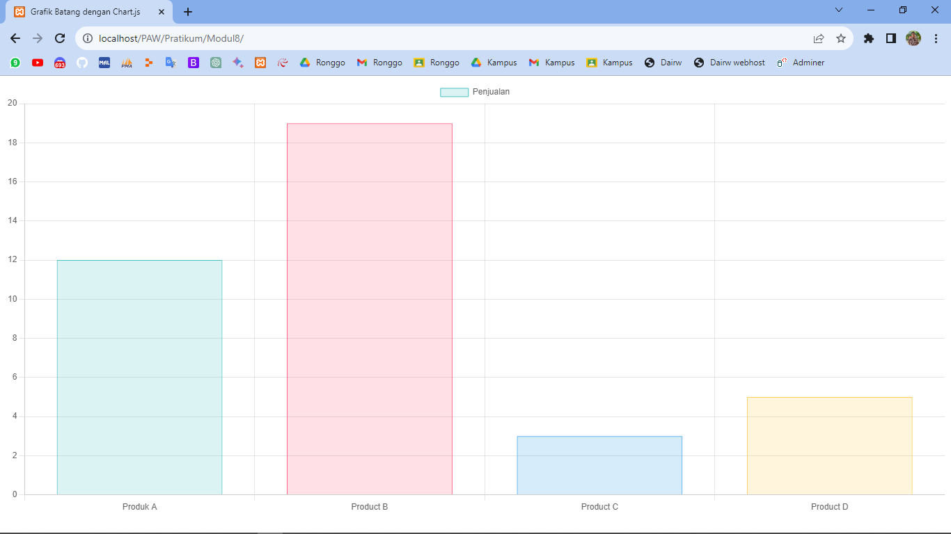

1. **Code Program**

|  |
| --- |
| 1. <button onclick="window.print()">Print this page</button> |

**Penjelasan Code Program:**

**Hasil Running Program:**

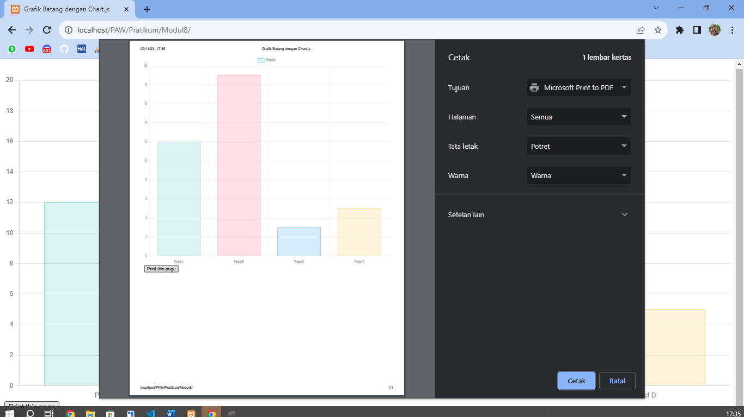

1. **Code Program**

|  |
| --- |
| 1. <?php 2. header("Content-Type: application/vnd.ms-excel; charset=utf-8"); 3. header("Content-Disposition: attachment; filename=laporan.xls"); |

**Penjelasan Code Program:**

**Hasil Running Program:**

